Practical Class 2
Probability Distribution Analysis of Selected Continuous Variables by Outcome Group
Dataset used: data_for_analysis
Selected variables: hormone1, hormone2, lipid_pero1, antioxidant1, сarb_metabolism

Introduction
This report presents a probability distribution analysis of selected continuous variables from the dataset data_for_analysis, grouped by the variable outcome, as required in Task 1 of Practical Class 2. The task requires two main objectives: first, to estimate the distribution of continuous variables by group, and second, to create a table containing descriptive statistics together with the parameters of the selected distribution for each group.
The analysis was limited to five selected non-lipid continuous variables: hormone1, hormone2, lipid_pero1, antioxidant1, and сarb_metabolism. These variables were chosen to ensure that none of the lipid variables lipids1 to lipids5 were included in the final analysis scope, in line with the selected reporting plan and the task instruction that excludes lipids5 from the main assignment dataset.
Aim
The aim of this report is to estimate the most appropriate probability distribution for each selected continuous variable by outcome group and to summarize the descriptive statistics and fitted distribution parameters in a final combined table.

Data description
The working dataset data_for_analysis was obtained by merging factor_data-1.csv and imputed_data-1.csv using the common identifier record_id, following the approach shown in the practical class script. According to the assignment description, the merged dataset contains the grouping variable outcome and a set of continuous biomedical variables including hormone, lipid, metabolic, lipid peroxidation, and antioxidant indicators.
For this report, only the following five continuous non-lipid variables were analyzed:
hormone1
hormone2
lipid_pero1
antioxidant1
сarb_metabolism
The variable outcome was used to divide the observations into groups for all analyses.

Methodology
The analysis was performed in R using the MASS package and the fitdistr() function, which estimates distribution parameters by maximum likelihood. For each selected variable, the data were separated into groups according to outcome, and candidate continuous distributions were fitted within each group.
Three candidate distributions were considered where applicable:
- Normal
- Lognormal
- Exponential
The best-fitting distribution for each variable and outcome group was selected using the Bayesian Information Criterion. The BIC is a model selection measure that balances model fit and complexity, and the model with the lowest BIC value is preferred.
In addition to model fitting, descriptive statistics were calculated for each selected variable by outcome group. These descriptive statistics included:
- Sample size (n)
- Mean
- Standard deviation
- Median
- Minimum
- First quartile (Q1)
- Third quartile (Q3)
- Maximum
Histograms were also generated separately for each selected variable to visually inspect the shape of the data distribution before interpreting the fitted models. Each histogram was labeled using the actual variable name.

Results
Distribution estimation by group
The first objective of the task was to estimate the distribution of continuous variables by outcome group. This objective was achieved by fitting candidate distributions separately for each selected variable within each outcome category and selecting the distribution with the smallest BIC value. The results showed that the best-fitting distributions varied across variables and, in some cases, across outcome groups. Most selected variables were best represented by the lognormal distribution, while some outcome-group combinations were better fitted by the normal distribution, indicating that the distributional form was not identical across all variables or groups.
Descriptive statistics and fitted parameters
The second objective of the task was to create a table containing descriptive statistics and the parameters of the selected distribution by group. This objective was achieved through the combined final table, which included descriptive measures and the fitted distribution information for each variable-outcome combination.
Table 1 presents the descriptive statistics and the parameters of the selected best-fitting probability distributions for the five selected continuous variables by outcome group. The best distribution in each case was determined using the Bayesian Information Criterion, where lower BIC values indicate better model fit.

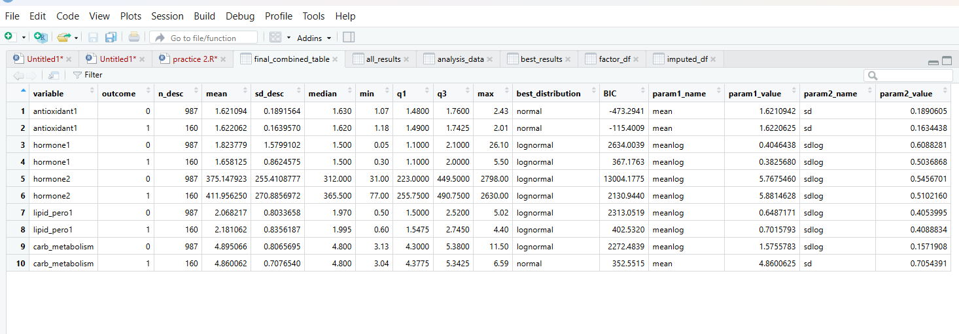
Table 1. Descriptive statistics and selected distribution parameters for the five selected variables by outcome group.

Based on the generated table, antioxidant1 was best fitted by the normal distribution in both outcome groups, while hormone1, hormone2, and lipid_pero1 were best fitted by the lognormal distribution in both groups. For сarb_metabolism, the best-fitting distribution differed by group, with the lognormal distribution selected for outcome = 0 and the normal distribution selected for outcome = 1, showing that group-specific fitting can reveal differences that would be missed in pooled analysis.
Histogram presentation
Separate histograms were generated for each of the five selected variables in order to visually assess the distributional shape of the data before and alongside formal model fitting. These histograms support the interpretation of skewness, spread, and concentration of values and complement the BIC-based distribution selection.

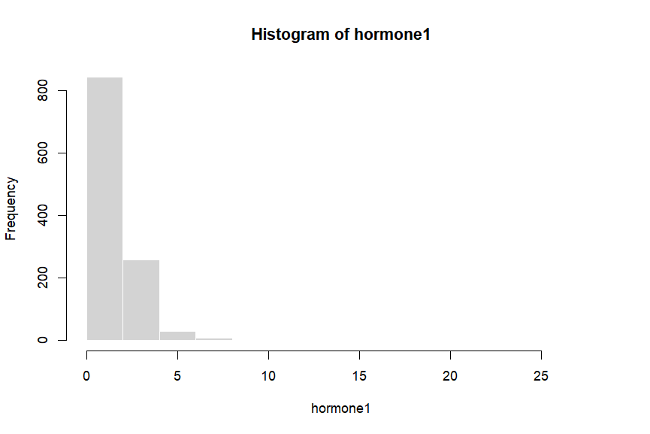
Figure 1: Histogram of Hormone 1

The histogram of hormone1 shows the general shape of the variable distribution in the selected sample. Visual inspection suggests whether the data are closer to a symmetric or positively skewed form, which supports later comparison among fitted models

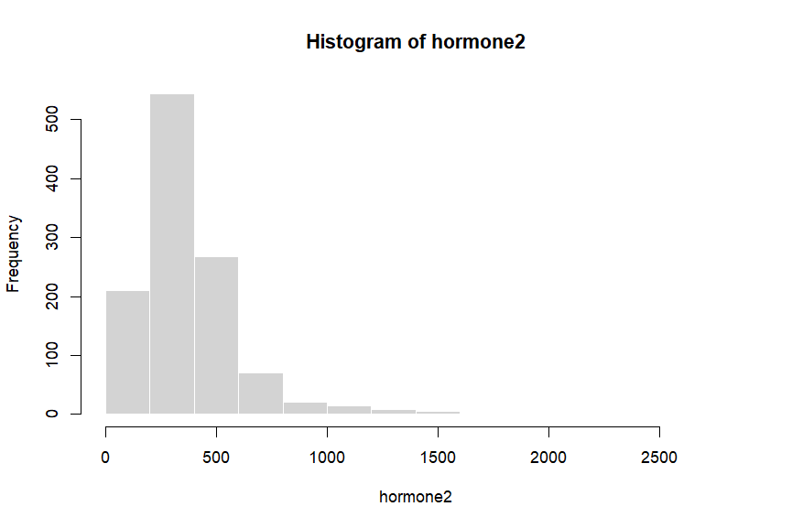
Figure 2: Histogram of Hormone 2
The histogram of hormone2 provides an initial visual impression of distributional form. This figure is useful for comparing the observed shape with the final selected theoretical distribution.

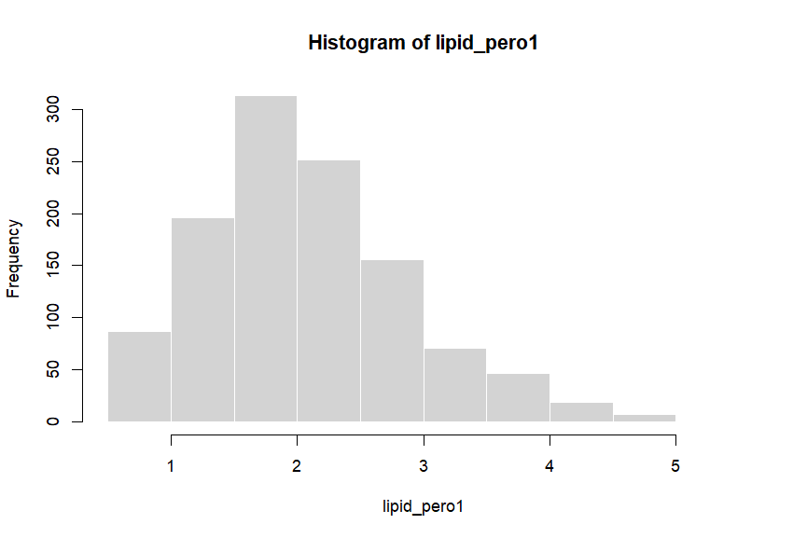
Figure 3: Histogram of Lipid_pero 1
The histogram of lipid_pero1 illustrates the frequency pattern of observations and helps identify whether a positively skewed distribution may be plausible

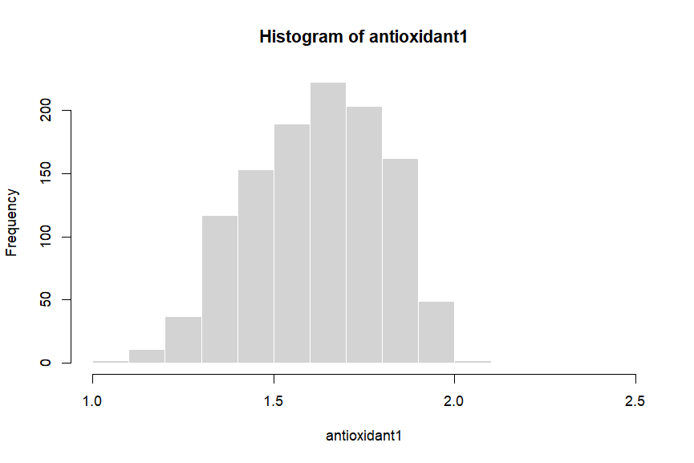
Figure 4: Histogram of antioxidant1

The histogram of antioxidant1 allows visual inspection of spread and skewness before formal model fitting

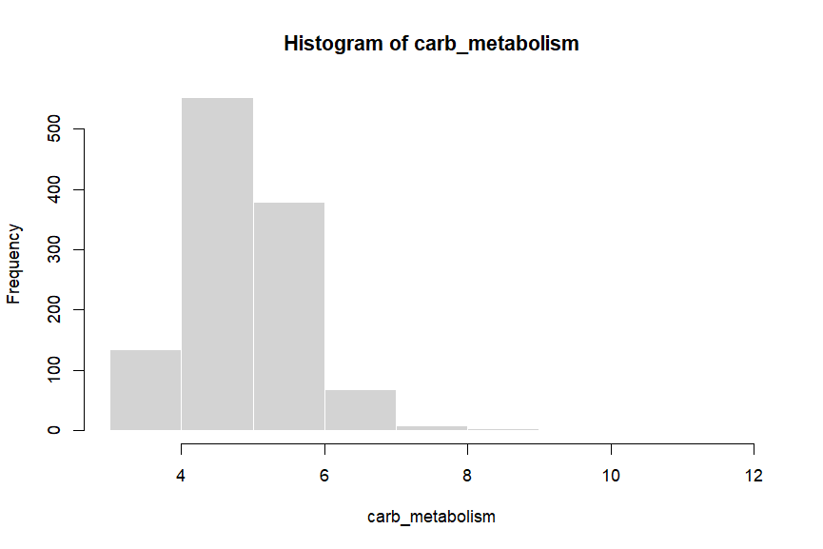
Figure 5: Histogram of carb_metabolism
The histogram of сarb_metabolism provides the visual basis for evaluating the plausibility of candidate continuous distributions

Discussion
The results demonstrate that continuous biomedical variables may follow different probability distributions depending on both the variable itself and the subgroup under analysis. Variables such as hormone1, hormone2, and lipid_pero1 were more consistent with lognormal distributions, suggesting positive skewness and non-symmetric spread, while antioxidant1 showed a pattern more compatible with the normal distribution in both outcome groups.
The grouped approach used in this report is appropriate because the task explicitly requires estimation by outcome group rather than across the full dataset. This is important because pooled analysis can mask subgroup differences, whereas separate fitting allows the underlying distributional form to be compared more accurately across categories.
The addition of descriptive statistics strengthens the analysis by providing a broader numerical summary of each variable beyond the fitted model alone. Measures such as the mean, median, quartiles, and standard deviation allow the lecturer to see both the central tendency and the spread of each variable in each outcome group, while the distribution parameters show the formal probabilistic representation selected for that same group.

Conclusion
This report addressed both required questions in Task 1 of Practical Class 2. First, the probability distributions of five selected continuous non-lipid variables were estimated separately by outcome group using maximum likelihood estimation and BIC-based model selection. Second, a final combined table was created to present descriptive statistics together with the parameters of the selected best-fitting distributions for each variable and group.
The findings show that the best-fitting distribution differs across variables and can also differ across outcome groups, confirming the value of subgroup-based analysis. The combination of histogram inspection, descriptive statistics, and BIC-based model fitting provides a complete and interpretable statistical summary of the selected variables in the dataset.

